**WEEK 4  
Spring REST using Spring Boot 3**

Create a Spring Web Project using Maven

**SpringLearnApplication.java**

package com.cognizant;

import org.springframework.boot.SpringApplication;

import org.springframework.boot.autoconfigure.SpringBootApplication;

@SpringBootApplication

public class SpringLearnApplication {

public static void main(String[] args) {

SpringApplication.run(SpringLearnApplication.class, args);

System.out.println("SpringLearnApplication started...");

}

}  
**OUTPUT:**

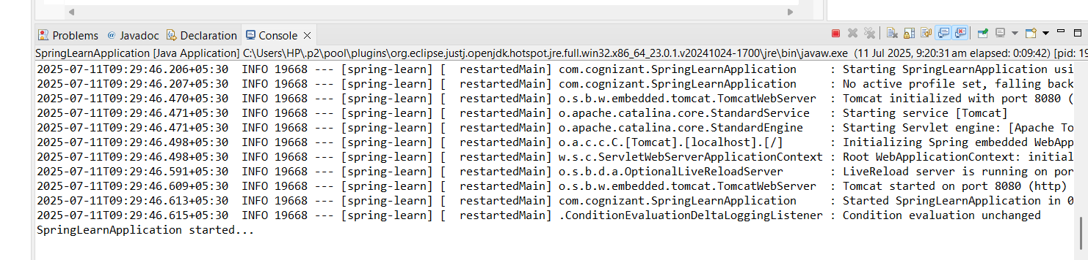

**Spring Core – Load Country from Spring Configuration XML**

Country.java

**package** com.cognizant.springlearn;

**import** org.slf4j.Logger;

**import** org.slf4j.LoggerFactory;

**public** **class** Country {

**private** String code;

**private** String name;

**private** **static** **final** Logger ***LOGGER*** = LoggerFactory.*getLogger*(Country.**class**);

**public** Country() {

***LOGGER***.debug("Inside Country Constructor.");

}

**public** String getCode() {

***LOGGER***.debug("Inside getCode()");

**return** code;

}

**public** **void** setCode(String code) {

***LOGGER***.debug("Inside setCode()");

**this**.code = code;

}

**public** String getName() {

***LOGGER***.debug("Inside getName()");

**return** name;

}

**public** **void** setName(String name) {

***LOGGER***.debug("Inside setName()");

**this**.name = name;

}

@Override

**public** String toString() {

**return** "Country [code=" + code + ", name=" + name + "]";

}

}

SpringLearnApplication.java  
**package** com.cognizant;

**import** org.slf4j.Logger;

**import** org.slf4j.LoggerFactory;

**import** org.springframework.context.ApplicationContext;

**import** org.springframework.context.support.ClassPathXmlApplicationContext;

**import** com.cognizant.springlearn.Country;

**public** **class** SpringLearnApplication {

**private** **static** **final** Logger ***LOGGER*** = LoggerFactory.*getLogger*(SpringLearnApplication.**class**);

**public** **static** **void** main(String[] args) {

System.***out***.println("Inside main()");

*displayCountry*();

}

**public** **static** **void** displayCountry() {

System.***out***.println("Inside displayCountry()");

ApplicationContext context = **new** ClassPathXmlApplicationContext("country.xml");

Country country = context.getBean("country", Country.**class**);

System.***out***.println("Country: " + country);

}

}

**OUTPUT:**

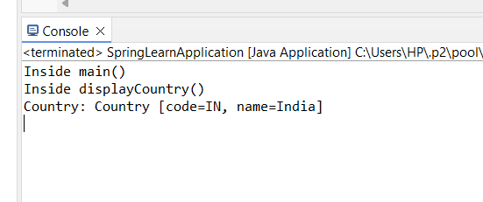

Hello World RESTful Web Service

HelloController.java

**package** com.cognizant.springlearn.controller;

**import** org.slf4j.Logger;

**import** org.slf4j.LoggerFactory;

**import** org.springframework.web.bind.annotation.GetMapping;

**import** org.springframework.web.bind.annotation.RestController;

@RestController

**public** **class** HelloController {

**private** **static** **final** Logger ***LOGGER*** = LoggerFactory.*getLogger*(HelloController.**class**);

@GetMapping("/hello")

**public** String sayHello() {

***LOGGER***.debug("Start - sayHello()");

String message = "Hello World!!";

***LOGGER***.debug("End - sayHello()");

**return** message;

}

}

**OUTPUT:**

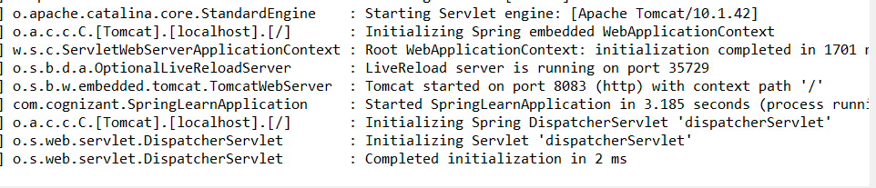

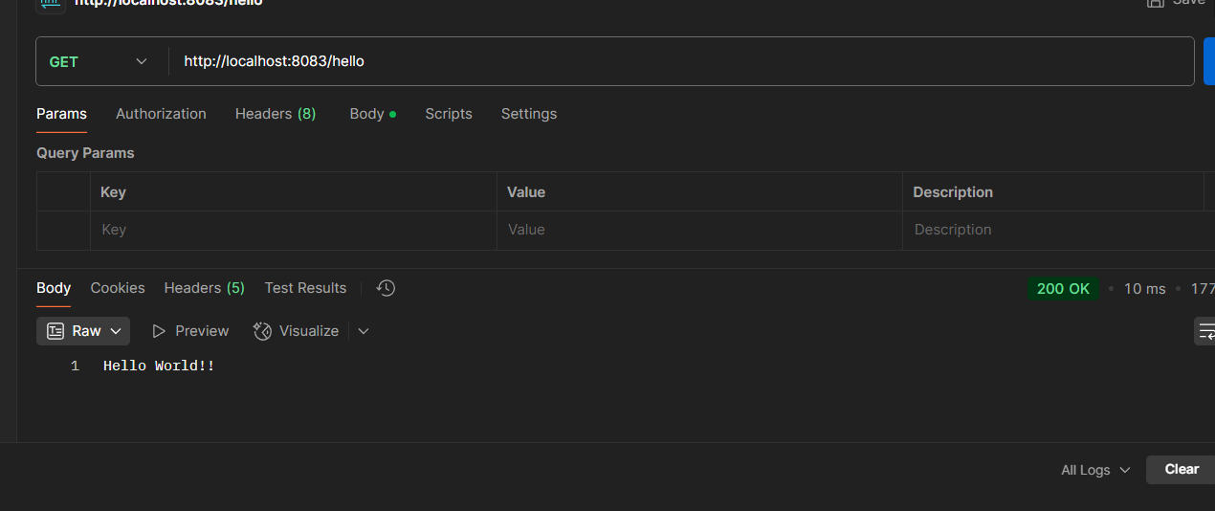

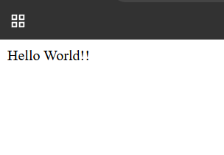

**REST - Country Web Service**

CountryController.java

**package** com.cognizant.springlearn.controller;

**import** org.slf4j.Logger;

**import** org.slf4j.LoggerFactory;

**import** org.springframework.context.ApplicationContext;

**import** org.springframework.context.support.ClassPathXmlApplicationContext;

**import** org.springframework.web.bind.annotation.RequestMapping;

**import** org.springframework.web.bind.annotation.RestController;

**import** com.cognizant.springlearn.Country;

@RestController

**public** **class** CountryController {

**private** **static** **final** Logger ***LOGGER*** = LoggerFactory.*getLogger*(CountryController.**class**);

@RequestMapping("/country")

**public** Country getCountryIndia() {

***LOGGER***.debug("Start - getCountryIndia()");

ApplicationContext context = **new** ClassPathXmlApplicationContext("country.xml");

Country country = context.getBean("country", Country.**class**);

***LOGGER***.debug("End - getCountryIndia()");

**return** country;

}

}

SpringLearnApplication.java

**package** com.cognizant;

**import** org.springframework.boot.SpringApplication;

**import** org.springframework.boot.autoconfigure.SpringBootApplication;

@SpringBootApplication

**public** **class** SpringLearnApplication {

**public** **static** **void** main(String[] args) {

System.***out***.println("Inside main()");

SpringApplication.*run*(SpringLearnApplication.**class**, args);

}

}

**OUTPUT:**

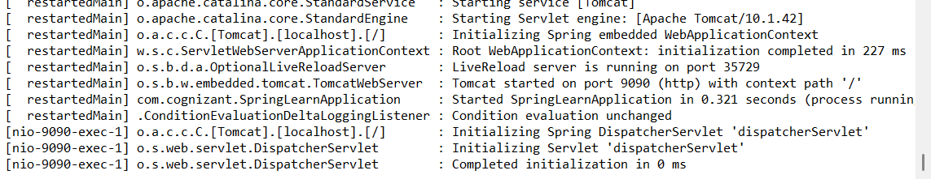

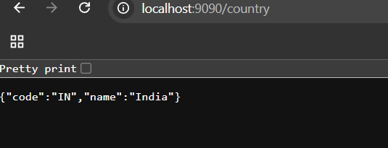

1. What happens in the controller method?

@RequestMapping("/country")

public Country getCountryIndia() {

...

return country;

}

When a client sends a GET request to /country, this method runs.

It:

Loads the Spring XML file (country.xml)

Fetches the bean with ID "country" — which is the India object

Returns the Country Java object as a response

1. **How is the Java bean converted to JSON?**

Spring Boot uses Jackson (a JSON processor) behind the scenes.

When a method in a controller annotated with @RestController returns an object like Country, Spring Boot:

* Converts the object to JSON using Jackson
* Sets the HTTP response’s Content-Type to application/json
* Sends it as the response body

3. In network tab of developer tools show the HTTP header details received

1. Right-click on page → Inspect
2. Go to Network tab
3. Refresh http://localhost:9090/country
4. Click the /country request

Check:

* Status Code: 200 OK
* Content-Type: application/json
* Request Method: GET
* Response: Should show {"code":"IN", "name":"India"}

**REST - Get country based on country code   
CountryController.java**

**package** com.cognizant.springlearn.controller;

**import** org.slf4j.Logger;

**import** org.slf4j.LoggerFactory;

**import** org.springframework.beans.factory.annotation.Autowired;

**import** org.springframework.web.bind.annotation.*;

**import** com.cognizant.springlearn.Country;

**import** com.cognizant.springlearn.service.CountryService;

@RestController

**public** **class** CountryController {

**private** **static** **final** Logger ***LOGGER*** = LoggerFactory.*getLogger*(CountryController.**class**);

@Autowired

**private** CountryService countryService;

@GetMapping("/countries/{code}")

**public** Country getCountry(@PathVariable String code) {

***LOGGER***.debug("Start - getCountry() with code: {}", code);

Country country = countryService.getCountry(code);

***LOGGER***.debug("End - getCountry(): {}", country);

**return** country;

}

}

**OUTPUT:**

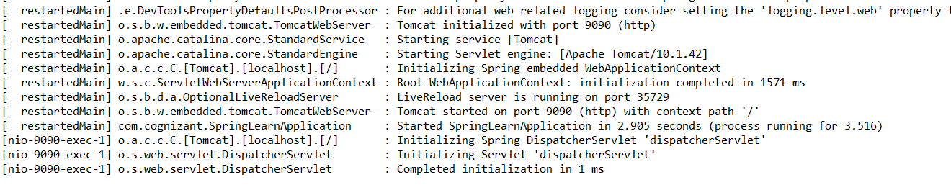

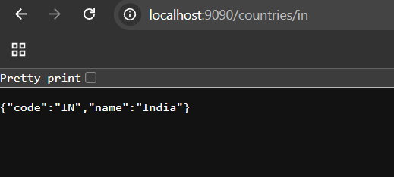

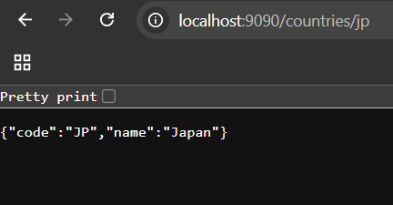

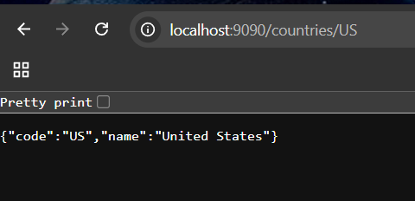

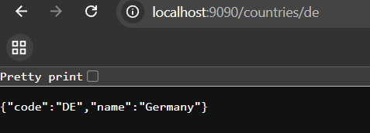

**Creating users and roles in Spring Security**

**Country.java**

**package** com.cognizant.springlearn.model;

**public** **class** Country {

**private** String code;

**private** String name;

**public** Country() {}

**public** Country(String code, String name) {

**this**.code = code;

**this**.name = name;

}

**public** String getCode() {

**return** code;

}

**public** **void** setCode(String code) {

**this**.code = code;

}

**public** String getName() {

**return** name;

}

**public** **void** setName(String name) {

**this**.name = name;

}

}

**CountryService.java**

**package** com.cognizant.springlearn.service;

**import** com.cognizant.springlearn.model.Country;

**import** org.springframework.stereotype.Service;

**import** org.springframework.context.ApplicationContext;

**import** org.springframework.context.support.ClassPathXmlApplicationContext;

**import** java.util.List;

@Service

**public** **class** CountryService {

**public** List<Country> getAllCountries() {

ApplicationContext context = **new** ClassPathXmlApplicationContext("country.xml");

List<Country> countries = (List<Country>) context.getBean("countryList");

**return** countries;

}

}

**OUTPUT:**

curl -u user:pwd <http://localhost:9090/countries>



